Workshop Worksheet
Hogging the Spotlight for Your eBay Auctions

1. Quiz: Name three ways to attract more attention to your auction.

- __________________________
- __________________________
- __________________________

2. Let’s analyze the keywords included on the Keywords tab.

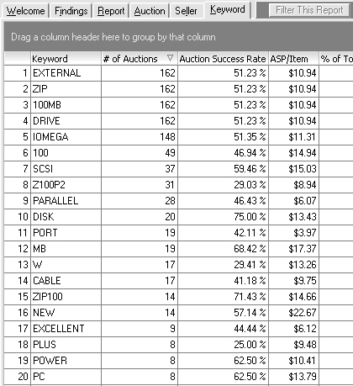
Image 1

- In the table below, write the top seven keywords we discover would make our auction the most successful. Also include the number of auctions the keyword was included in:

Keyword | # of Auctions with the Word | Success Rate | Sales Price
 |  | % | $
 |  | % | $
 |  | % | $
 |  | % | $
 |  | % | $
 |  | % | $
 |  | % | $

- Write an auction title that includes the keywords we’ve identified as those belonging to the most successful auctions. (Remember, eBay limits the length of auction titles to 55 characters.)
_______________________________________________________

3. Quiz: Describe how to set up the data in the DeepAnalysis keywords tab to easily find successful auction title keywords:
________________________________________________________________________________________________________________________________________________________________________________________________________________________

4. Let’s explore the best category for our auction.

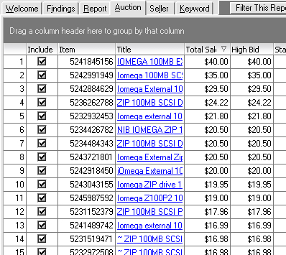
Image 2
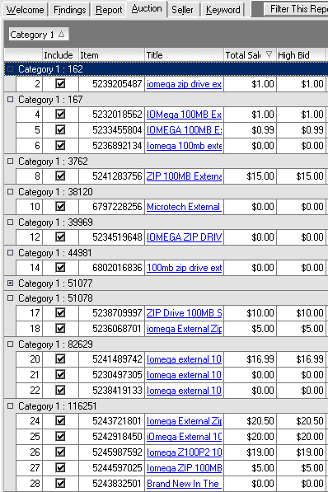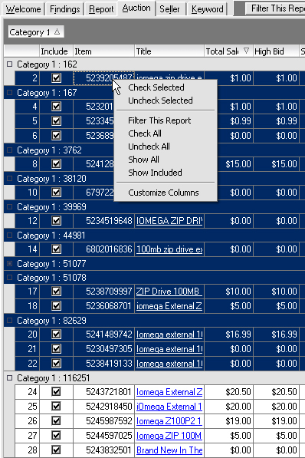
Image 3 Image 4

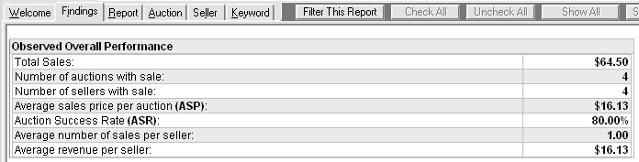
Image 5 (Category #116251 data)

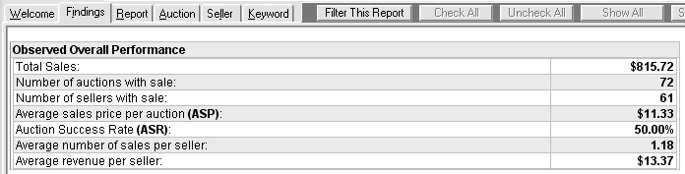
Image 6 (Category #51077 data)

Category # | # of Auctions with a sale | Success Rate | Sales Price
116251 |  | % | $
51077 |  | % | $

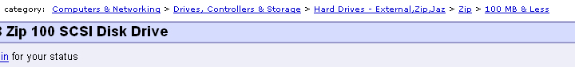
Image 8 (Category #116251)

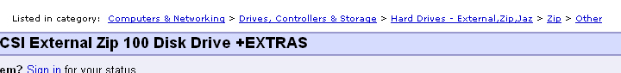
Image 7 (Category #51077)

- Write the category you think will give you the best chances of getting your auction seen.
_________________________________

5. Quiz: Why did we only consider 2 of the possible 10 categories? What was wrong with the other 8?
________________________________________________________________________

________________________________________________________________________

________________________________________________________________________

6. Now we’re going to determine which eBay features might attract more attention to our auction. To do this, we’ll compare the average success statistics (in the Executive Summary) to the success statistics for the eBay listing features (in the Feature Analysis report).
Executive Summary
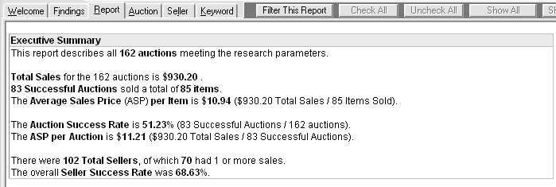
Image 9

Feature Analysis Report
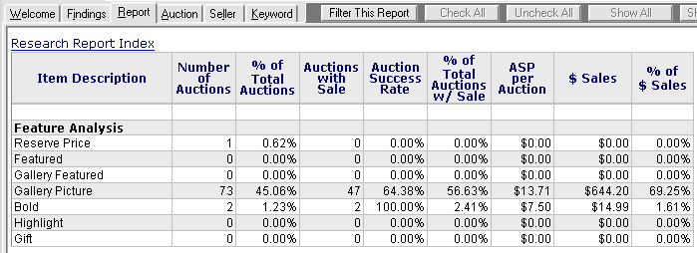
Image 10

a. Executive Summary Average Success Rate: _______________________
b. Executive Summary Average Sales Price: _______________________
c. Which listing features have a better Auction Success Rate than the Average Success Rate on the Executive Summary? ___________________________________________________________
d. Which listing features have a better ASP (Average Selling Price) than the ASP on the Executive Summary?
___________________________________________________________
e. Compare the listing Feature statistics with the Executive Summary statistics to recommend features you think I should order when I list my auction:
___________________________________________________________
7. In review, please write the three things I should do to attract more attention to my auction:
- Auction Title: ____________________________________________
- Category: _______________________________________________
- Listing Features: __________________________________________

You can get the Sellers Guide at http://www.hammertap.com/support/sellersguide.pdf.

