Tele-Workshop Worksheet
Treasure Hunting with eBay Research

1. Think of three things you already own that you might sell on eBay.

- __________________________
- __________________________
- __________________________

2. Guess what percent of each type of auction sold and the average price they sold for.

 | Average Success Rate  (percent of total auctions sold) | Average Sales Price  (average price for the  auctions that sold)
Sconces | % | $
Sony VCR | % | $
Mirror | % | $

Based on your guesses above, which item do you think I should sell? ____________________

3. Let’s practice narrowing your research.

- First, enter a keyword(s) in DeepAnalysis. What keyword(s) would you use to research a Sony VCR?
_______________________
_______________________
_______________________
- After scanning the Title column heading on the Auctions tab, what are some more words that match the Sony VCR that you might include to help narrow your research?
_______________________
_______________________
_______________________

- What are some words in the auction titles that don’t match the VCR?
________________________
________________________
________________________
________________________
- On the DeepAnalysis research panel, click the Keyword Research button. Then, select the Advanced Keyword Research radio button. Now you can do advanced keyword research.
- In the Keywords field, enter the words you wrote down for keywords you want to include in your search (section b). Place a plus (+) sign in front of each of those words. Then, also in the Keywords field, enter the words you want to exclude from your search (section c). Place a (-) sign in front of each of those.
- Click Start.

- Narrowing research quiz:
  - Why does narrowing your research give you more meaningful research results? ____________________________________________________________________________________________________________________________________________________________________________________
  - Name two ways to narrow your research.
______________________
______________________
- Let’s compare the research for the three products to figure out which I should sell. Circle the success rate and the average sales price for each item in the Executive Summaries below. Then, record the statistics in the table provided.
VCR Executive Summary:
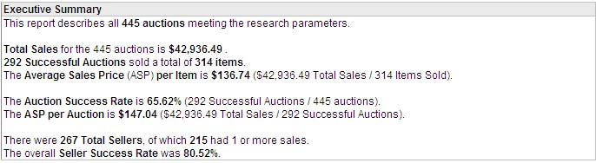
Sconces Executive Summary:
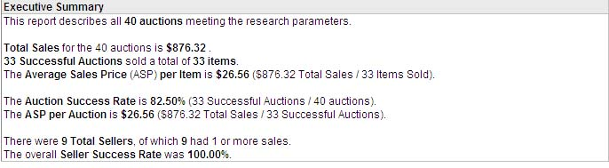
Mirror Executive Summary:
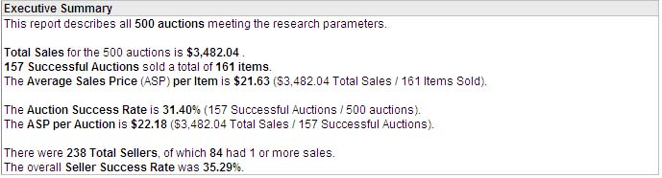
 | Average Success Rate  (percent of total auctions sold) | Average Sales Price  (average price for the  auctions that sold) | Which Item Should I Sell?
Sony VCR | % | $
Sconces | % | $
Mirror | % | $
Place a checkmark next to the item you think I should sell. Compare the data above with your guesses in question #2.

- Now let’s boost our chances of selling. Look at the following statistics and circle the one that gives us the best chances of selling.
VCR Executive Summary:

Best Auction Type
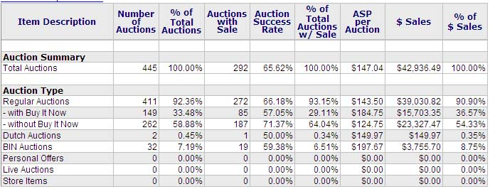
- Executive Summary Average Success Rate: _______________________
- Executive Summary Average Sales Price: _______________________
- What is the Auction Type with the best Auction Success Rate?
_________________
- What is the Auction Type with the best ASP (Average Sales Price)?
_________________

- Compare the Auction Type statistics with the Executive Summary statistics to recommend the Auction Type you think I should list with:
_________________
Most Useful eBay Features
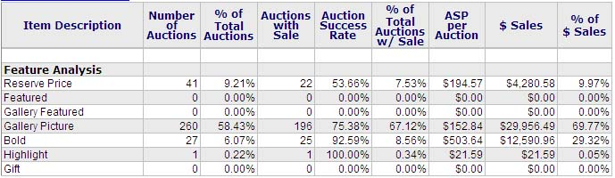

- Executive Summary Average Success Rate: _______________________
- Executive Summary Average Sales Price: _______________________
- Which listing features have a better Auction Success Rate than the Average Success Rate on the Executive Summary? ___________________________________________________________
- Which listing features have a better ASP (Average Selling Price) than the ASP on the Executive Summary?
___________________________________________________________
- Compare the listing Feature statistics with the Executive Summary statistics to recommend features you think I should order when I list my auction:
___________________________________________________________
Best Starting Day
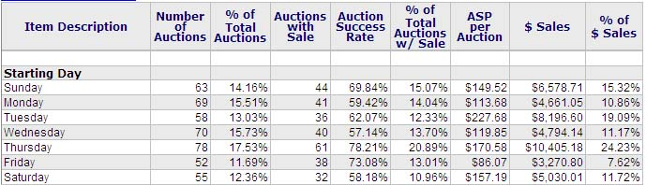

- Executive Summary Average Success Rate: _______________________
- Executive Summary Average Sales Price: _______________________
- Which Starting Day has the best Auction Success Rate?
_________________
- Which Starting Day has the best ASP (Average Sales Price)?
_________________

- Compare the Starting Day statistics with the Executive Summary statistics to recommend the Starting Day you think I should list with:
_________________
Best Ending Day
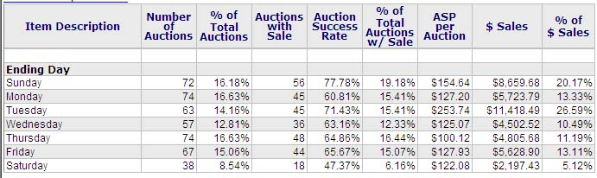
- Executive Summary Average Success Rate: _______________________
- Executive Summary Average Sales Price: _______________________
- Which Ending Day has the best Auction Success Rate?
_________________
- Which Ending Day has the best ASP (Average Sales Price)?
_________________

- Compare the Ending Day statistics with the Executive Summary statistics to recommend the Ending Day you think I should list with:
_________________
- In summary, write the auction elements you recommended in #6 for the VCR. This gives us an overview of how I should list the auction to boost my chances of selling and my sales price:
best auction type __________________
best eBay Features _________________
best listing day ____________________
best ending day ___________________
- Assignment: Print this worksheet again and work through it for your own three products to determine what you should sell and how to list it.

You can get the Sellers Guide at http://www.hammertap.com/support/sellersguide.pdf.

